CSCI 362 Project Phase IV:

Complete Software Final Report

Fraction Worksheet Creator

**Prepared by**

**Olga Sheehan, Eric Holm,**

**Sara Hakkoum, Ethan Fiero**

**Elementary Engineers**

**Framingham State University**

**2016**

# Table of Contents

Table of Contents 1

I. Change History 3

II. Purpose of Project 4

III. System Overview 4

User Classes and Characteristics 5

Operating Environment 6

IV. Market Search 6

V. Feature Description 7

Admin System Features 7

Teacher System Features 7

Student System Features 9

General System Features 9

VI. Requirements 11

Functional Requirements 11

Non-Functional Requirements 12

Performance Requirements 12

Security Requirements 12

Software Quality Attributes 12

Business Rules 12

Software Interfaces 13

VII. System Model 14

User 14

Admin 15

Teacher 15

Student 16

Class 18

Worksheet 18

Difficulty 19

FractionGenerator (FNG) 20

Equation 21

Fraction 22

WS_Master 22

IX. Design 26

Design Goal 26

User Interface 26

System Service 28

X. Test Plans 28

Testing Scenario 28

Testing Schedule 29

References 31

# I. Change History

|  |  |  |  |
| --- | --- | --- | --- |
| **Name** | **Date** | **Reason For Changes** | **Version** |
| Release 1 | 02/18/2016 | Initial release | 1.0 |
| Release 2 | 03/03/2016 | User Interface Prototype  Revised after receiving customer feedback | 1.1 |
| Release 3 | 04/14/2016 | System Modeling and Prototype  Revised after receiving customer feedback | 1.2 |
| Release 4 | 04/27/2016 | Complete Software | 1.3 |

# II. Purpose of Project

The “Fraction Worksheet Creator” (FWC) is an off-line worksheet generation tool designed by Elementary Engineers to help elementary school teachers to create a lot of exercises for students to study and practice fractions. This project is being produced by students at Framingham State University with help from Dr. Andrew Jung.

The fractions worksheets are randomly created and never repeated so the teachers have an endless supply of quality fractions worksheets to use in the classroom or at home. The generated worksheets can contain fraction problems of various difficulty levels, from basic addition and subtraction problems with visuals and images suitable for small children, to quite advanced fraction equations.

The worksheets created with “Fraction Worksheet Creator” are not pre-designed but are randomly generated based on a complex set of algorithms corresponding to the specific mathematical structure of each type of worksheet. This allows for virtually unlimited original worksheets. Furthermore, FWC will also generate an answer sheet. The worksheets will be created as PDF documents which are automatically opened on the computer once the generating process is done.

The “Fraction Worksheet Creator” worksheets are free to print, easy to use, and very flexible.

# III. System Overview

The Fraction Worksheet Creator (FWC) is a new stand-alone product that allows teachers and students to create random exercise worksheets to practice operations with fractions. There exist many alternative online fraction worksheet creators. However, this system is accessible offline and stores worksheets and user information for all teachers and students that share the workstation on which the product is installed

Figure 1 below demonstrates the entities of the system and its interfaces, which may be altered from each release to the next to meet the requirements in this specification.

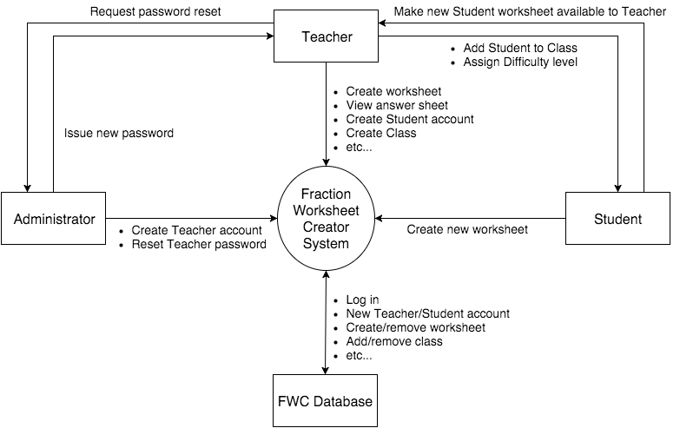

**Figure 1** *–**Context diagram for release 1.0 of the Fraction Worksheet Creator*

## User Classes and Characteristics

|  |  |
| --- | --- |
| Administrator | An Administrator is a teacher or other employee at the school in which the FWC will be used who installs the FWC on a workstation to be used by Teachers and Students. The Administrator shall use the FWC system only to create and remove Teacher user accounts, as well as reset Teacher passwords on-demand. |
| Teacher (favored) | A Teacher is an employee at the school that uses the FWC to create random exercise worksheets for fractions to distribute to students in his/her classes. The Teacher must have access to the answer sheet of every worksheet he/she creates or that his/her Students create. The Teacher can create Classes and rosters for them, creating an account for each Student in a class and providing the students with their usernames and passwords in order to access the FWC. The Teacher can assign difficulty levels for the worksheets that each of his/her Students creates. The Teacher has access to all worksheets he/she has previously created in the FWC system. |
| Student | A Student is a participant in one of a Teacher’s classes that shall be able to create random fraction worksheets of the Student’s assigned difficulty level. Like the Teacher, the Student is able to refer to worksheets that he/she previously created. |

## Operating Environment

* The FWC shall operate with any Operating System that has Java installed.
* The FWC shall interface with Adobe Reader in order to open the created worksheets as PDF files and allow the user to save or print the worksheets.
* The FWC shall operate with any system that has a printer installed.

# IV. Market Search

“Fraction Worksheet Creator” (FWC) software has certain advantages with which it may be competing among other software tools. This outline compares popular software systems for printing fraction worksheets, which share at least one feature with FMC.

We will compare Fraction Worksheet Creator with following software tools for printing worksheets.

|  |  |  |  |  |
| --- | --- | --- | --- | --- |
| **Software Name** | **Developer** | | **Description** | |
| **WorkSheet Maker**  http://worksheet-maker.software.informer.com/2.0/ | iKodeko | An off-line worksheet generation tool designed to help teachers and parents to help their students learn math faster by doing a lot of exercises. Features: addition, subtraction, multiplication, division, MDAS with fractions, algebra, statistics, number series, factors, prime factors, measuring angles, Roman numerals, greater than and less than, addition tables, multiplication tables, number words and digits, and tracing words and numbers. | |
| **Microsoft Math Worksheet Generator**  http://microsoft-math-worksheet-generator.software.informer.com/ | Microsoft Education Labs | The best thing about Microsoft Math Worksheet Generator is that it doesn’t only generate the worksheets with math problems from the existing samples, but it can also analyze a math problem that you provide and generate the worksheets containing exercises and equations based on that problem.   The worksheets will be created as MS Word documents which are automatically opened on your computer once the generating process is done. There’s no need to worry if Word is not installed on your computer. If that’s the case, the worksheets are created as HMTL pages and are displayed in your default browser. The answer sheet opens as a separate page.   Microsoft Math Worksheet Generator is very easy-to-use, simple and self-explanatory. | |
| **Math Generator**  http://download.cnet.com/Math-Generator/3000-2053_4-46543.html | CANELA Software | Math Generator is user friendly. The program guides you all the way in creating your math problems. Just a few key strokes will create the worksheet/test you desire. Most users claim that they never needed to use the manual to use Math Generator. | |

These software tools are comprehensive, standalone, which do not require a permanent Internet connection like FWC. The advantages of Fraction Worksheet Creator like quick, easy installation, creating fraction worksheets of different difficulties only for 4 Grade make this software tool to have all chances to become competitive among another software popular among teachers and students of elementary school.

# V. Feature Description

## Admin System Features

*Features that will be utilized only by the Administrator Account*

Requirement: Teacher Registration

Description: The admin shall be able to register teacher accounts. The admin shall utilize the ADMIN GUI Panel to create new accounts for any teachers using the software. The admin shall create the teacher’s username and the system will provide a randomly generated eight character’s password.

Requirement: Teacher Password Reset

Description: The admin shall be able to reset teacher account passwords. The admin shall utilize the ADMIN GUI Panel to reset forgotten teacher passwords. The admin shall click a <Reset Password> button for the teacher. Doing so will randomly generate a new eight character password. This password is temporary and can be provided to the teacher outside the FWC software.

## Teacher System Features

*Features that will be utilized by Teacher user accounts*

Requirement: Teacher System Access

Description: The teacher shall be able to access the system using a username / password. This information shall be entered in to the login screen. Username to be provided by the administrator. Password to be randomly generated by the admin. The teacher will be required to change their password the first time they login.

Requirement: Teacher Password Reset

Description: The teacher shall be able to request a password reset. Clicking on the <Password Reset> button on the login screen will prompt a pop-up on the ADMIN GUI Panel the next time the Admin logs in.

Requirement: Teacher Worksheet Selection

Description: The teacher shall be able to select any worksheet regardless of difficulty and problem type. All available difficulties and worksheets will be visible on the main worksheet creation page.

Requirement: Worksheet Parameter Options

Description: The teacher shall be able to select a range of values for numerator and denominator for intermediate and advanced worksheets. These values will be used during the creation of the problems for the worksheet.

Requirement: Student Worksheet Review

Description: The teacher shall be able to review student generated worksheets and answer sheets. Using the Class Roster Panel the teacher will be able to view a list of worksheets generated by the students. This list will include the student name, date generated, the difficulty and worksheet type created. Clicking on a listing will open a PDF copy of the worksheet and answer sheet.

Requirement: Student Worksheet Deletion

Description: The teacher shall be able to delete student generated worksheets and answer sheets. Using the Class Roster Panel the teacher will be able to remove listings for generated worksheets. Permanently removing those listings from the database.

Requirement: Class Roster Creation

Description: The teacher shall be able to create rosters for each class they teach. Using the Class Roster Panel the teacher will be able to create a roster of students for each course they teach. Allowing the teacher to see all students in a particular class at a glance. Data entered for the class roster will be used as part of the worksheet header.

Requirement: Student Login Management

Description: The teacher shall be able to create / modify / delete logins for students. Using the Student Data Panel the teacher will be able to add new students, modify their username / password, and delete the student account.

Requirement: Student Difficulty Management

Description: The teacher shall be able to set difficulty levels for each student. Using the Student Data Panel the teacher will be able to assign available difficulty levels to the student.

## Student System Features

*Features that will be utilized by Student user accounts*

Requirement: Student System Access

Description: The student shall be able to access the system using a username / password. This information shall be entered in to the login screen. Username and password to be provided by the teacher.

Requirement: Student Password Reset

Description: The student shall be able to request a password reset. Clicking on the <Password Reset> button on the login screen will prompt a pop-up on the Teacher Class Roster Panel the next time they log in.

Requirement: Student Worksheet Option

Description: The student shall be able to select various problem types based on assigned difficulty level. Based on the difficulty level set by the teacher, only those worksheets will be visible on the main worksheet creation page.

## General System Features

*Features that will be utilized by both Student and Teacher user accounts*

Requirement: Admin Account Setup

Description: During the initial installation of the FWC, the system shall require an admin account be created. This account will be responsible for administration of teacher accounts. Both for account creation and password management.

Requirement: Graphical User Interface

Description: The system shall provide a graphical user interface to access all components of the software.

Requirement: Help System

Description: The system shall provide help for each screen displayed in the GUI. This help will provide instructions for navigating that section of the software.

Requirement: Worksheet Difficulty

Description: The system shall provide three levels of worksheet difficulty. Those levels will be named Beginner, Intermediate and Advanced.

Requirement: Worksheet Types

Description: The system shall provide three worksheet types per difficulty level.

Beginner – All three will be image based problems.

Worksheet 1 – Convert Picture to Fraction (10 Problems)

Worksheet 2 – Order images from least to greatest (10 Problems)

Worksheet 3 – Addition of Picture Fractions (10 Problems)

Intermediate – These will be simpler problems without images.

Worksheet 1 – Addition (20 Problems)

Worksheet 2 – Subtraction (20 Problems)

Worksheet 3 – Multiplication / Division (20 Problems)

Advanced – These will be word based problems.

Worksheet 1 – Addition (20 Problems)

Worksheet 2 – Subtraction (20 Problems)

Worksheet 3 – Multiplication / Division (20 Problems)

Requirement: Tutorial Content

Description: The system shall provide tutorial content for each worksheet. These will be video based tutorials that will walk users through solving an example problem for that worksheet type.

Requirement: Random Exercise Generation

Description: The system shall generate random exercises for each worksheet. The system shall use a randomly generated seed number that can be used to create the exercises. The seed will be stored for each worksheet / answer sheet retrieval.

Requirement: Worksheet Instructions

Description: The system shall generate instructions on the worksheet for each problem type. After the header information at the top, the next printed section on the worksheet will be an example problem with instructions for how to solve.

Requirement: Worksheet Output

Description: The system shall allow previewing, printing and saving worksheets and answer sheets via PDF. The system will save a PDF document, which will be automatically opened when the user requests a worksheet or answer sheet. Using the default options within Adobe Reader the user can save or print the document being previewed.

Requirement: Search Feature

Description: The system shall provide a search feature on the class roster screen to search for students and student worksheets. A search bar will be displayed. Text entered into this field will be compared to the class roster and any results for that text will be displayed in place of the all data available view.

# VI. Requirements

## Functional Requirements

*These are the non-technical versions of the Functional Requirements for the Fraction Worksheet Creator.*

*Requirements for the Admin System Features*

* The admin shall be able to register teacher accounts.
* The admin shall be able to reset teacher account passwords.

*Requirements for the General System Features*

* The system shall provide administrative privileges to an assigned user during installation.
* The system shall provide a graphical user interface for all software interactions.
* The system shall provide help for each screen displayed in the GUI.
* The system shall provide three levels of worksheet difficulty.
* The system shall provide three worksheet types per difficulty level.
* The system shall provide tutorial content for each worksheet.
* The system shall generate random exercises for each worksheet.
* The system shall generate instructions on the worksheet for each problem type.
* The system shall allow previewing, printing and saving worksheets and answer sheets via PDF.
* The system shall provide a search feature on the class roster screen to search for students and student worksheets.

*Requirements for the Teacher System Features*

* The teacher shall be able to access the system using a username / password.
* The teacher shall be able to request a password reset.
* The teacher shall be able to select any worksheet regardless of difficulty and problem type.
* The teacher shall be able to select a range of values for numerator and denominator for intermediate and advanced worksheets.
* The teacher shall be able to review student generated worksheets and answer sheets.
* The teacher shall be able to delete student generated worksheets and answer sheets.
* The teacher shall be able to create rosters for each class they teach.
* The teacher shall be able to create / modify / delete logins for students.
* The teacher shall be able to set difficulty levels for each student.

*Requirements for the Student System Features*

* The student shall be able to access the software using a username / password provided by the teacher.
* The student shall be able to request a password reset.
* The student shall be able to select various problem types based on assigned difficulty level.

## Non-Functional Requirements

*These are the non-technical versions of the Non-Functional Requirements for the Fraction Worksheet Creator*

* The system shall run on a Windows or Mac OS device running Java 8 or higher.
* The system shall have access to a printer to print worksheets and answer sheets.

## Performance Requirements

* **Number of Users:** The number of registered users shall not be limited, since the software shall be designed to be used by only one user at any given time.

## Security Requirements

* The system shall only allow unauthorized users to access the login and registration pages and the help utility.
* The system shall require a username and password to gain access to the FWC.
* The system shall store user passwords securely in a database.

## Software Quality Attributes

* **Correctness:** The system shall create a correct answer sheet for each generated worksheet.
* **Interoperability:** The system shall work seamlessly with the database to store login, teacher-student, worksheet, and answer sheet information and retrieve such information for use in the software.
* **Usability:** The system shall be easy to use and have an internal help utility to show users how to perform functions offered by the software.

## Business Rules

* The system shall allow the administrator to register teacher accounts.
* The system shall allow teachers to register student accounts and classes.
* The system shall allow students to generate worksheets and view previous worksheets, but not to view answer sheets.
* The system shall allow teachers to view answer sheets for worksheets created by their students.
* The system shall allow both teachers and students to access and delete existing worksheets from their previously created worksheets.

## Software Interfaces

* The software will interface with a database for the storage of user logins and worksheet generation seeds for answer sheet recall.
* The software will interface with an Application Program Interface (API) for the creation of Portable Document Format documents (PDFs). The PDFs will be how worksheets and answer sheets are formatted, saved and printed.
* The software will interface with Adobe Reader. Adobe Reader will be used to preview the worksheets and answer sheets. Adobe Reader provides printing and saving options that will be available to the users.

**Database Schema**

The database schema that is used in the FWC database is given below.

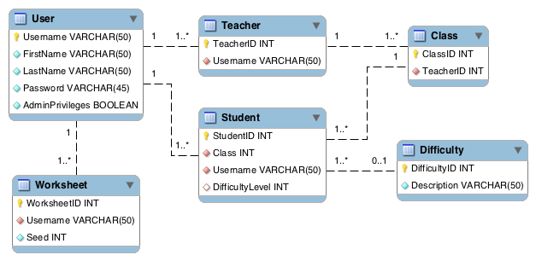

**Figure 2** *– Database schema diagram for release 1.0 of the Fraction Worksheet Creator*

# System Model

### User

Represents all common information between all user’s accounts. Users only have one username, first name, last name and an encrypted password. A user can update their username, first name, last name and their password in the database. The user contains the reset password option.

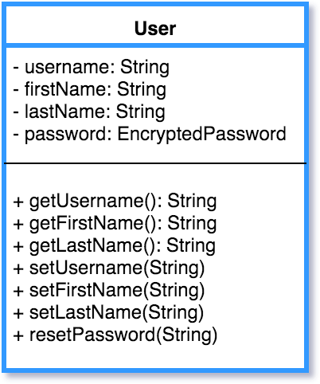

**EncryptedPassword**

Rather than store Users’ passwords as cleartext, we use EncryptedPasswords to store each password securely. Passwords are hashed using a salt, and the hash and salt are stored in EncryptedPassword. All Users have an EncryptedPassword. When a User logs in, the password entered is checked against that User’s EncryptedPassword using checkPassword(String).

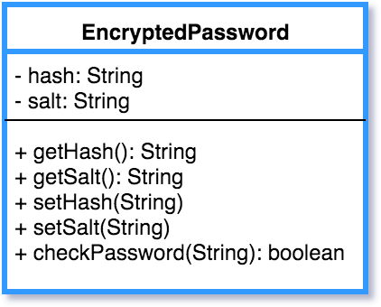

**Relationship Class Diagram**

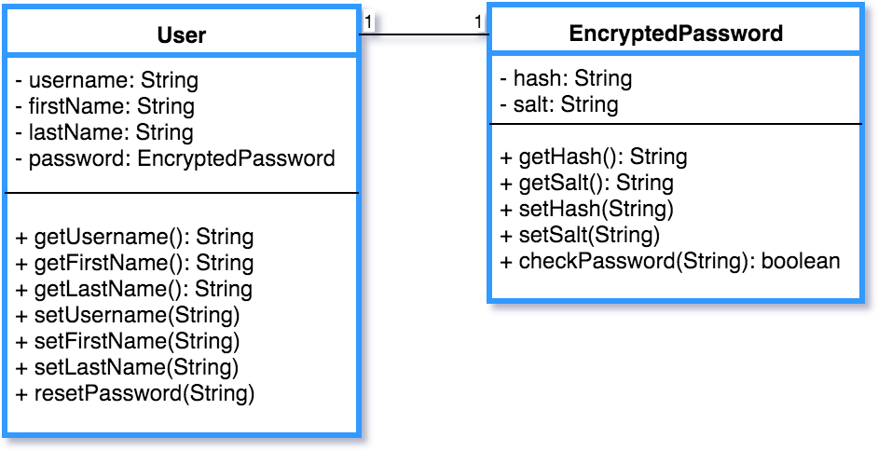

### Admin

Represents the information the Admin would have for their account. Admin will have and Array List of (Teachers and other Admins). They will also save their last 4 of their SSN, Birthday and First Job. These three fields will be used for the admin to reset their passwords; they will also be stored hashed. The admin can search through a list of teachers and admins. The admin can delete teachers and other admins and will update the database.

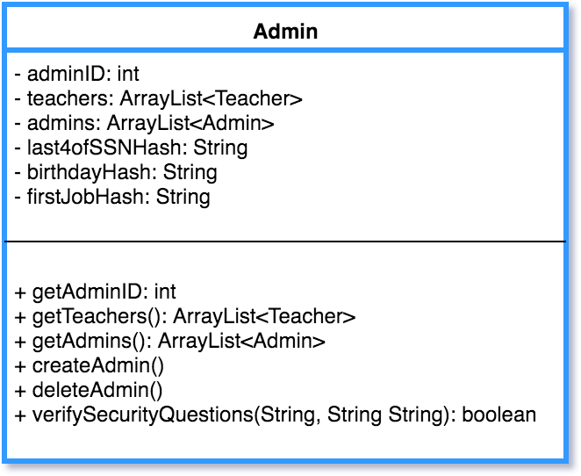

### Teacher

* Represents the information the teacher would have for their account. Teachers will have a teacher ID, along with three Array Lists (Classes, History of Worksheets). A teacher can search for a particular class and history of worksheets. A teacher will be allowed to create and delete classes and this will be updated in the database. The teacher can set the min and max of (numerator and denominator).

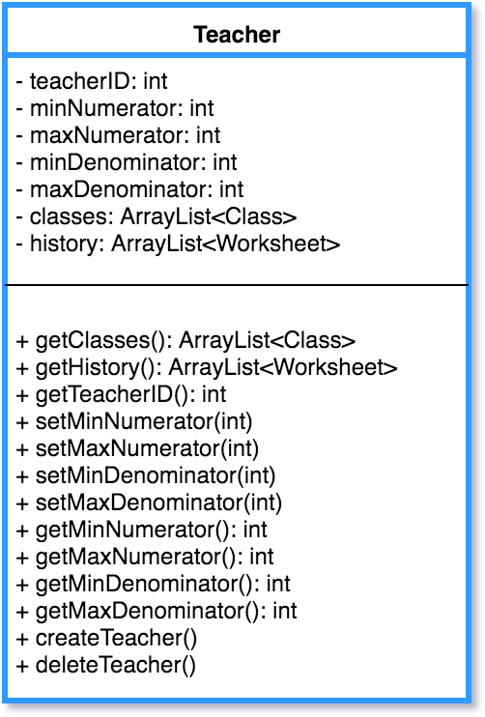

### Student

Represents the information the Student would have for their account. Student will be able see their history, difficultly level and class they are currently enrolled in. The Student will be able to search through their history of worksheets.

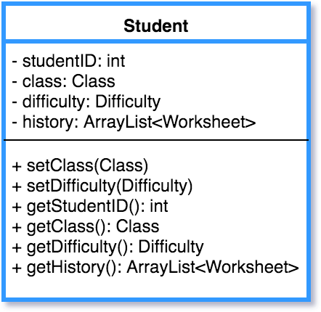

**Relationship Class Diagram**

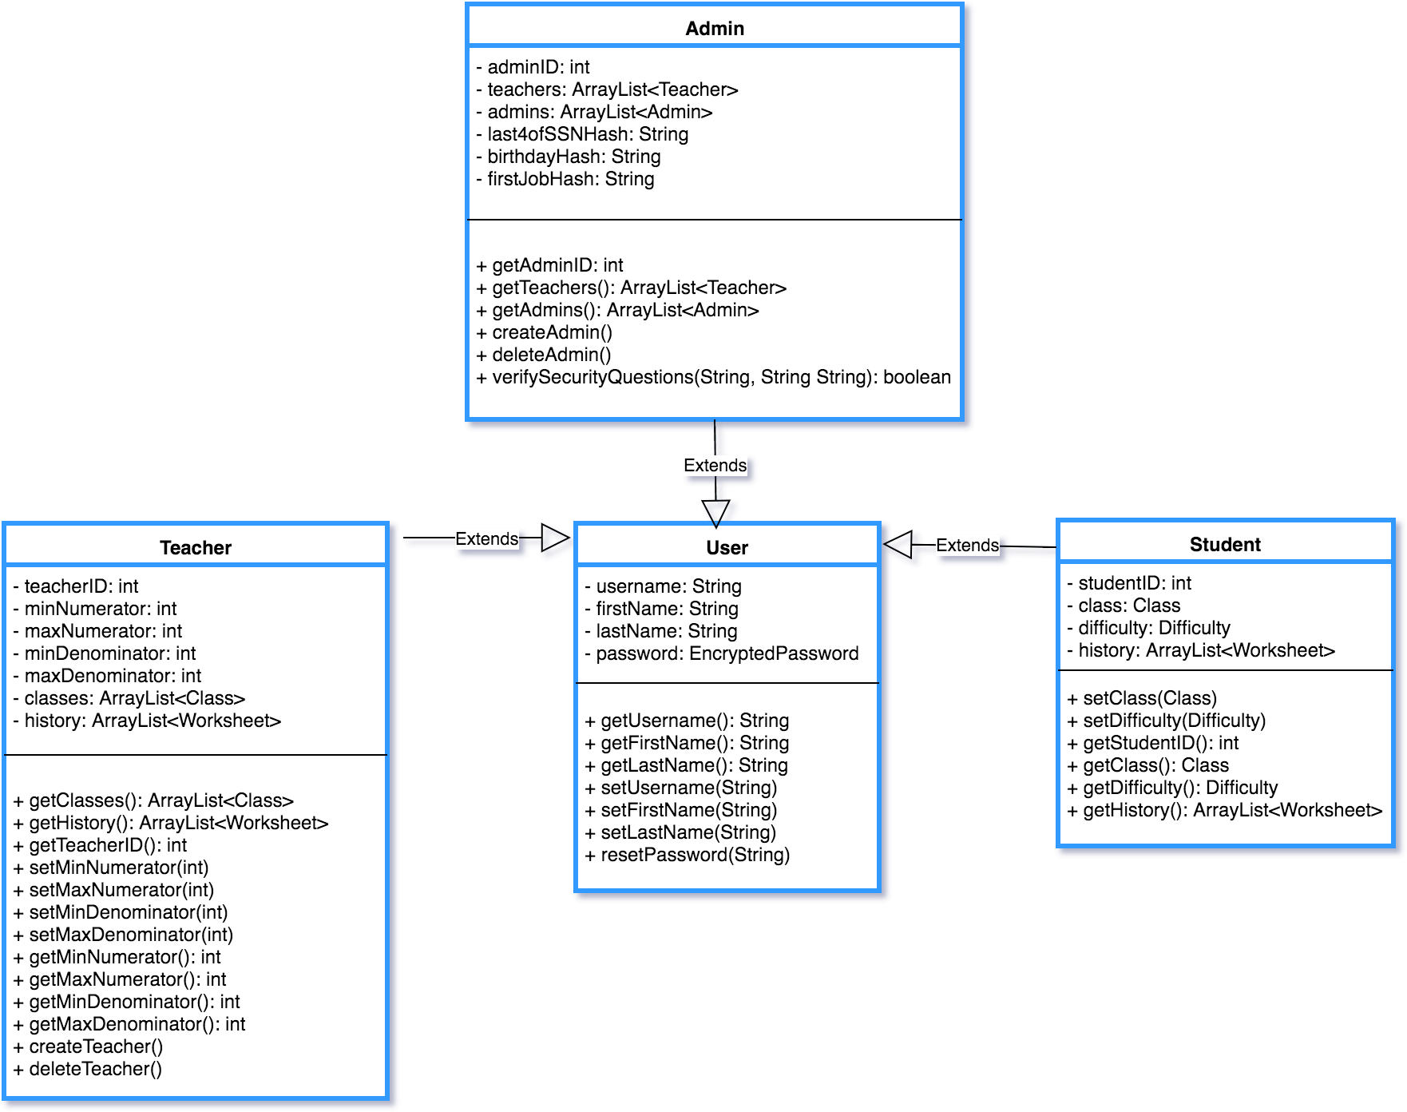

### Class

Represents a Class that a Teacher creates to add Students to. Classes have only one Teacher.

A Teacher can create, edit, and delete Classes. setClassName(String) can be used to edit a Class’ name, and the updated Class object can be used to update that Class in the database.

Students can be added to and removed from a Class. A Class can be searched for a particular Student.

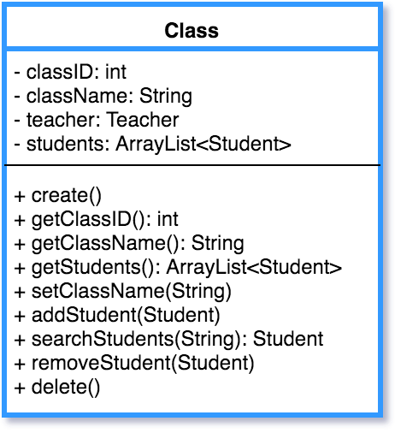

### Worksheet

A Teacher or a Student creates a Worksheet. When a Worksheet of any type is generated, a Worksheet object is used to represent it. Worksheet contains the information needed to recreate any Worksheet a Teacher or Student has created in the past. Deleting a Worksheet deletes that Worksheet from the corresponding User’s history.

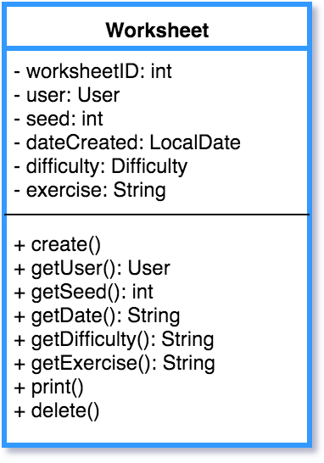

### Difficulty

Represents a difficulty level. There are 3 fixed Difficulties in the database: Beginner, Intermediate and Advanced. A Teacher assigns a Difficulty to a Student. Each Student has a Difficulty. A Student’s Difficulty can be changed using setDifficultyID(int) and using that Difficulty Object to update the database.

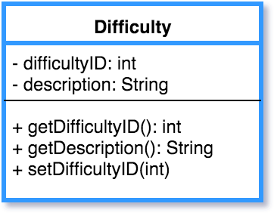

**Relationship Class Diagram**

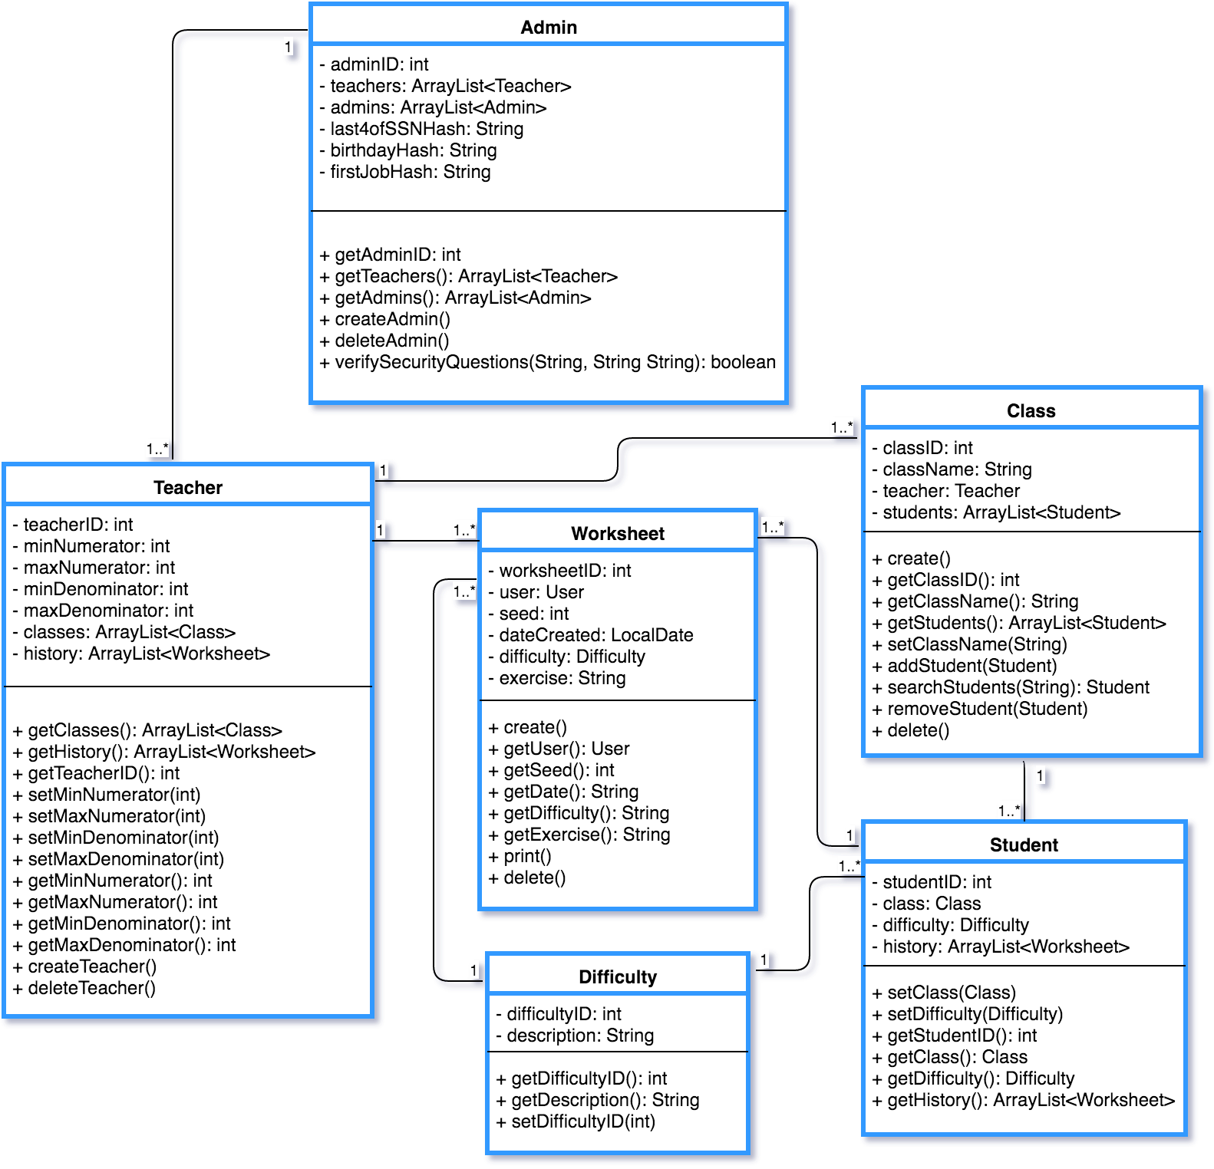

The **random** package of the Fraction Worksheet Creator is heart of programs , primary function of creating worksheets. There are multiple classes that build off one another to accomplish the task of generating the PDF files for the worksheets and answer sheets.

### FractionGenerator (FNG)

Generates a random set of fractions based on the parameters provided. This includes limits on the numerator, denominator, if whole numbers can be generated, and if matching denominators are required. Passes the fractions to calling classes as a List.

Equation

Forms equations based on the fractions generated by the FNG. Then based on the operator for this equation it calculates the answer, which is stored in an additional Fraction class object.

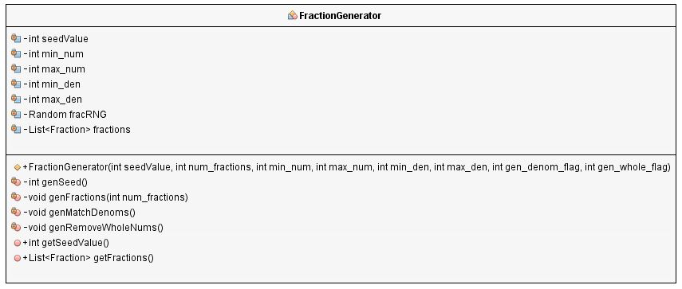

### Equation

Forms equations based on the fractions generated by the FNG. Then based on the operator for this equation it calculates the answer which is stored in an additional Fraction class object.

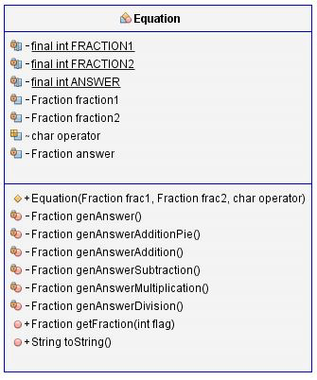

### Fraction

The base class for describing a fraction. Includes the numerator and denominator and provides the ability to reduce fractions to their lowest terms.

## 

### WS_Master

An abstract class used to store common data for all worksheets. This includes the list of fractions generated by the FNG, the seed value used to create the fractions and the base worksheet document. This includes common header and footer methods for all worksheets. Example and Problem methods must be implemented by all subclasses.

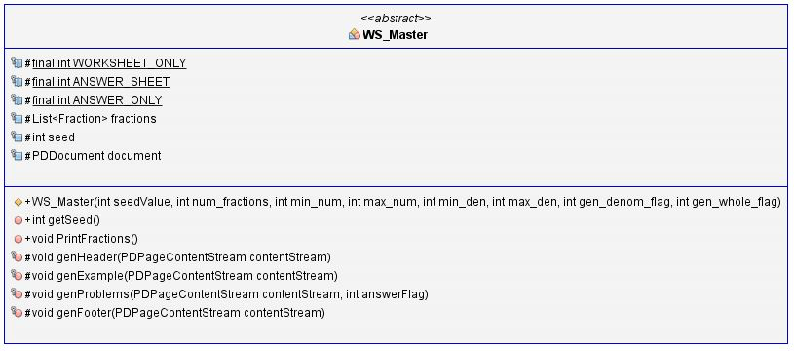

The following subclasses use WS_Master

WS_Beginner_LG – Beginner Least to Greatest problems

WS_Beginner_Pie – Beginner pie diagram to fraction problems

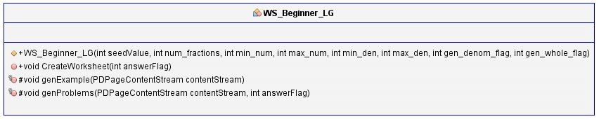

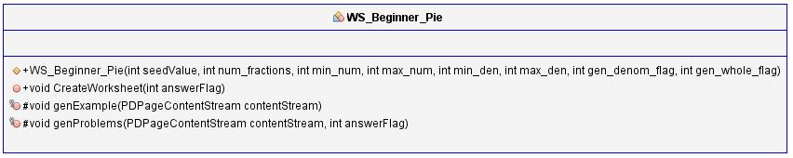

WS_Beginner_PieAdd – Beginner pie diagram addition problems

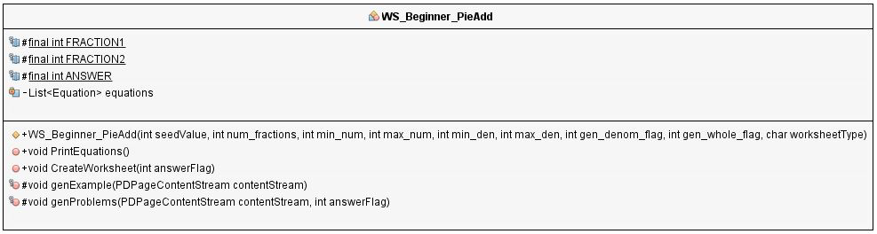

Beginner worksheets require separate subclasses since there is little commonality between the different worksheets at this level.

WS_Intermediate – All three intermediate worksheets (Addition, Subtraction, Multiplication/Division) use this one subclass since the only differentiator is the operator. The equation class handles the answers being different based on the operator used for the sheet.

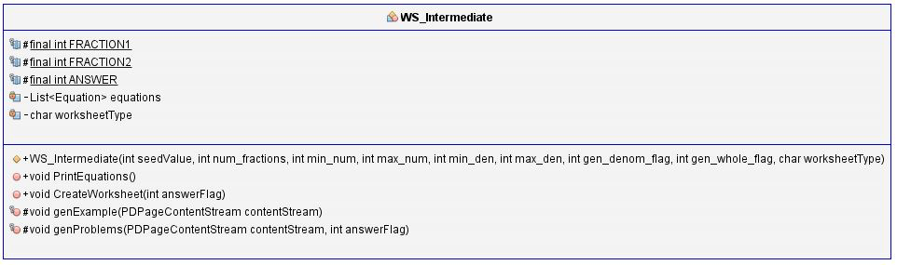

WS_Advanced – All three advanced worksheets (Addition, Subtraction, Multiplication/Division) use this one subclass since the only differentiator is the operator. The equation class handles the answers being different based on the operator used for the sheet.

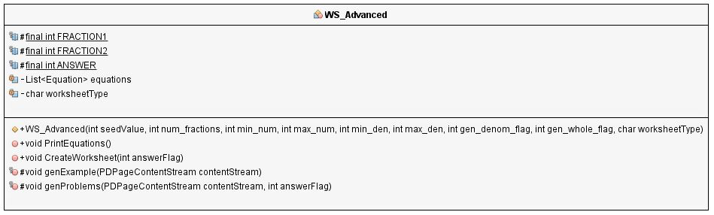

**Relationship Class Diagram**

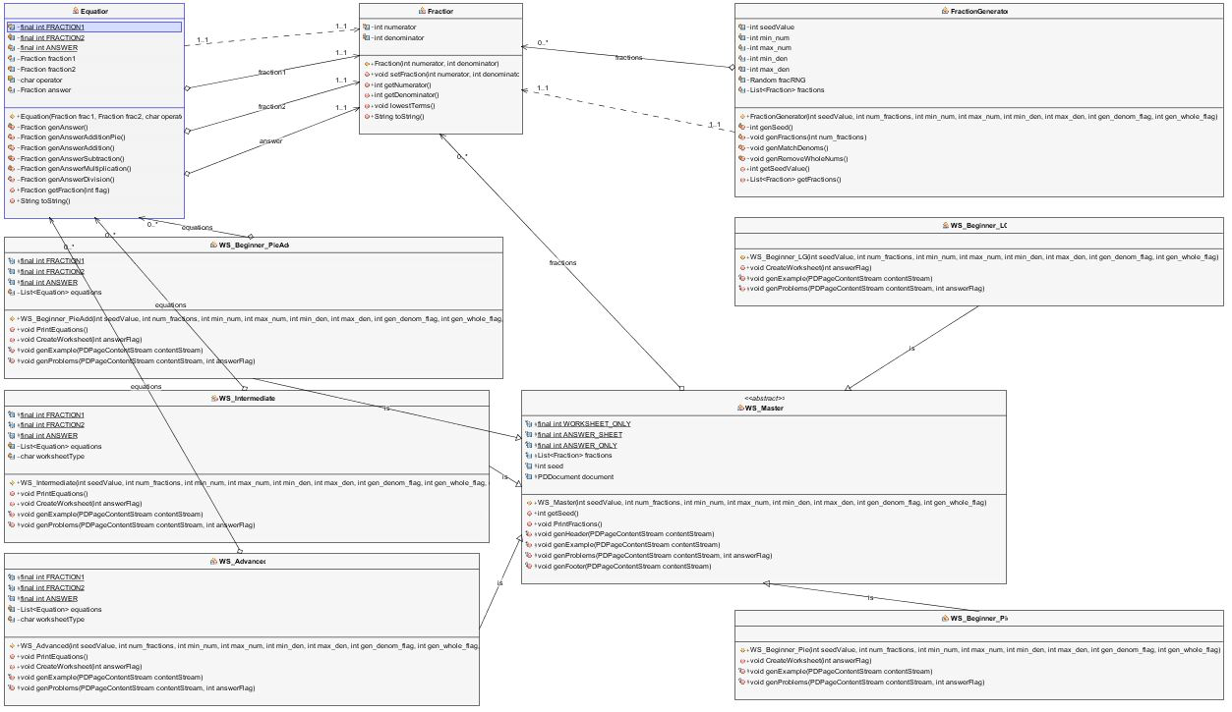

# Design

## Design Goal

A software design principle is a comprehensive and fundamental doctrine or rule that governs the creation of quality software designs.

The main goal of the Fraction Worksheet creator (FWC design) is to satisfy and delight the customer to meet all his needs. To delight customers requires that the FWC software does some

beneficial work for the customer, for example, quick generation fraction problems worksheets with answer key of different difficulty level.

The main principles of a good design that used in the developing of FWC are flexibility, extensibility and maintainability.

## User Interface

System users often judge a system by its interface rather than its functionality

It is important to design a good user Interface. A poorly designed interface can cause

a user to make catastrophic errors.

Design of the Fraction Worksheet Creator software tool should be easy-to –use and be attractive to user. Users of the FWC without experience can learn to use the system quickly. A full-screen interaction is possible with immediate access to anywhere on the screen of the FWC. The interface is consistent in that, wherever possible, comparable operations are activated in the same way.

The FWC user interface had following stages of development:

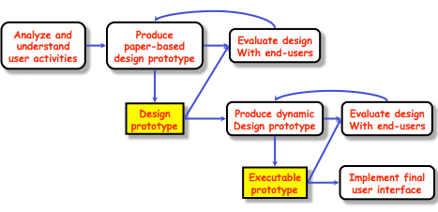

The FWC UI design takes account of the needs, experience and capabilities of

the system users, and the developers are aware of people’s physical and mental limitations (e.g.limited short-term memory) and should recognize that people make mistakes.

**Screen shots of the FWC UI Design:**

Login Page



Teacher Home Page



Teacher Worksheet History



Student Home Page



Administrator Teacher Registration Page



## System Service

* The FWC system shall provide a help utility within its user interface to aid all users with tasks to perform on the specific page on which the utility is invoked.
* The FWC system shall provide video tutorials for Teachers and Students to provide examples and aid for solving the fraction worksheets the FWC creates
* The system on which the FWC is installed also has Java installed.
* The system on which the FWC is installed also has Adobe Reader installed.
* Teachers and Students are able and permitted to save files to the system on which the FWC is installed.
* The FWC data does not need to be accessible from a workstation other than the one on which it is originally installed.

# Test Plans

## Testing Scenario

There is the testing scenario in narrative form that describes one way in which user as a teacher might use system of Fraction Worksheet Creator.

Example:

A teacher of Brown Elementary School is working with 4th Grade students. The students are working on the math unit Fractions. The teacher wants her students to practice fractions every day. She needs to print a lot of fractions worksheets from basic addition and subtraction problems to quite advanced fraction equations to her students. All students have different knowledge of fractions and need the worksheet of different level of difficulty from Beginner to Advanced. Today the teacher planned to work on Fraction Addition with her students. She logs on with her username and password to Fraction Worksheet Creator (FWC) system. On teacher homepage home screen she can choose the available worksheet for printing of different difficulties and exercise type. She needs to print fraction addition problems for Beginners and several worksheets for Intermediate level students. Teacher prints out the worksheets as PDF files and distributes among her students. Some students need extra help and teacher offers them to watch tutorial for how to add fractions for Beginner level clicking on button “Tutorials” on teacher homepage.

While kids are solving the fraction addition problems, teacher add a new class add a class, add a student to an existing class, search classes, modify classes, and view a class’ roster just by click on the button Classes. Also, on this page the teacher could check the worksheet history and profile of each student by clicking on the button Roster.

After students complete to fill in the worksheets, they give them to teacher to check. Teacher goes back to her homepage and click on button “History “. The History button takes the Teacher to this page, which displays her worksheet history, allowing the Teacher to print old worksheets, view their answer sheets, and delete them from the history. In the history table she highlights the row with the worksheets she printed out and clicks on button “Answer Key”. Now she can check each worksheet with unique answer key worksheet. It takes the teacher a couple minutes to grade the students’ addition fraction work.

## Testing Schedule

The Testing Schedule has been created to communicate the test approach to team members. It includes the task name, start and finish dates, and comments.

|  |  |  |  |
| --- | --- | --- | --- |
| **Task Name** | **Start** | **Finish** | **Comments** |
| Test Planning | 04/15/16 | 04/28/16 | After announcing Phase III |
| Review Requirements documents | 03/03/16 | 04/28/16 | Understand the feasibility of the requirements whether it is testable or not. |
| Create initial test estimates | 04/15/16 | 04/27/16 | Determine the overall testing strategy and process. |
| Development Testing: | 03/03/16 | 04/27/16 |  |
| Unit testing | 04/15/16 | 04/27/16 | Objects Classes should be done |
| Component testing | 04/15/16 | 04/27/16 | Testing on the component interfaces |
| System testing | 04/27/16 | 04/28/16 | Tested whole system |
| Deploy to QA test environment | 04/21/16 | 04/28/16 | Phase IV |
| Functional testing – Positive | 04/25/16 | 04/27/16 | Testing involves the application’s functions with valid input and also verifying that the outputs are correct |
| Functional testing – Negative | 04/26/16 | 04/26/16 | Testing involves exercising application functionality using a combination of invalid inputs, some unexpected operating conditions and by some other “out-of-bounds” scenarios |
| Resolution of final defects and final build testing | 04/21/16 | 04/28/16 | Identify the risks which are mitigated |
| Deploy to Staging environment | 04/28/16 | 04/28/16 | Test closure condition |
| Performance testing | 04/28/16 | 04/28/16 | Process of determining the speed and effectiveness of the FWC software program. |
| Release to Production | 04/27/16 | 04/28/16 | Successfully released! |

# References

[1] IEEE Software Engineering Standards Committee, “IEEE Std 830-1998, IEEE Recommended Practice for Software Requirements Specifications”, October 20, 1998.

[2] Fractions worksheet. (2016, February 12).

Retrieved from http://www.fractions4kids.com/worksheets/

[3] Basic Fractions Worksheets. (2016, February 12).

Retrieved from https://www.superteacherworksheets.com/fractions-basic.html

[4] Fraction worksheets 1.Fraction addition, subtraction, multiplication, and division. (2016, February 12). Retrieved from https://www.homeschoolmath.net/worksheets/fraction.php

[5] Test and Worksheet Generators for Math Teachers. Home Page. (2016, February 12). Retrieved from https://www.kutasoftware.com/freeipa.html

[6] Microsoft Math Worksheet Generator Software. (2016, February 12).

Retrieved from http://microsoft-math-worksheet-generator.software.informer.com/